
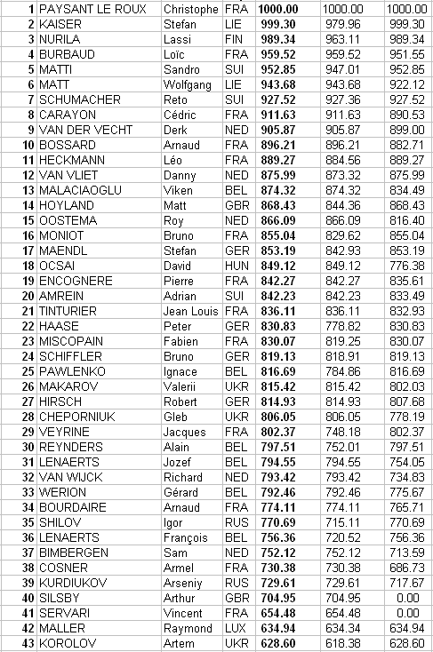
Final ranking updated after removing 4 pilots for which the
FAI licence was not valid for 2016

